**DX Spots Window**

# Hal Miller KB1ZQ, Geoff Anderson G3NPA, Jim Hargrave W5IFP, Aki Yoshida JA1NLX and Gerry Hohn VE6LB

### 2.10.1 Callsigns

This pop-up menu, allows the user to display yet another pop-up menu in order to set the call signs to be used by the Telnet & Cluster and Local Host Tab Panels of the Telnet Cluster window and Data Terminal window.

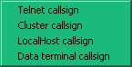

DXSW_4

Clicking on any one of the selections will display a dialog box, allowing the user to enter a callsign to be used for the selected tab panel or Data Terminal window.

### 2.10.2 Appearance

This menu allows the user to select different color schemes and message selections to "individualize" the DX Spots window

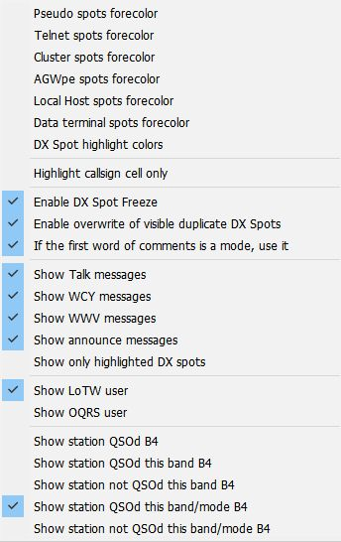

New DXSW_5

**Colors**

Selecting Pseudo, Telnet, Cluster, or Data Terminal spots foreground color displays a color selection box that allows the user to select individual forecolors for the connection being posted.

**DX Spot highlight colors**

Selecting the Worked / Confirmed/Credited colors opens a window that sets the background colors to be used in the DX Spot Window for each spot that meets the specified selection. The color displayed is based on the user's Band Plan to determine bands and modes. The color selection is made using a standard Windows Color Dialog Box, by clicking on the color to be selected.

The one exception to the above is the selection of the LoTW/OQRS/LoTW & OQRS user color. In this case the highlight is applied to the "?" (leftmost) column in the DX Spot Window.

The details of syntax and logic to highlight is explained in paragraph 2.9.5 Alerts.

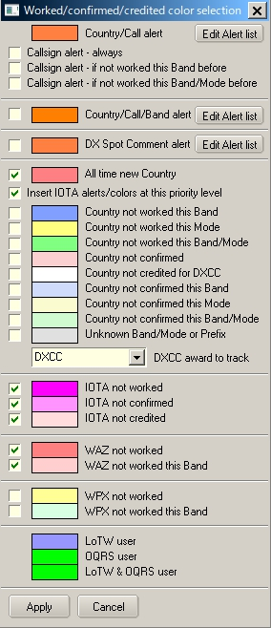

DXSW_6

For Country/Callsign alert, clicking “Edit Alert list” shows an Edit list of Callsigns to highlight table.

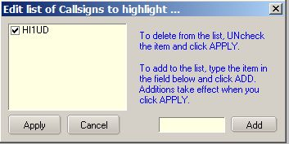

DXSW_6A

For Country/Call/Band/ alert, clicking “Edit Alert list” shows Setup Conditional Country Alerts table. Check Edit this alert box to start edit. See details in the paragraph Alerts.

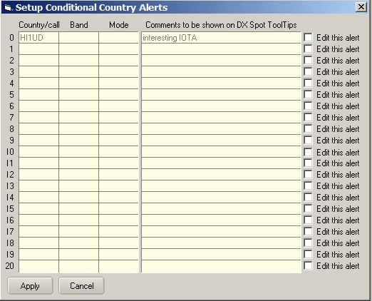

DXSW_6B

For DX Spot comment alert, clicking “Edit Alert list” shows Edit list of Comments to highlight the table.

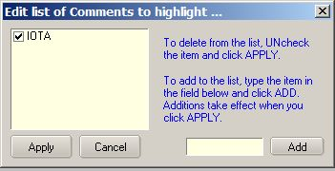

DXSW_6C

The check boxes to the left allow the user to determine which, then they can simply uncheck that color selection.

The entry 6 from the top of the table is determined by the selection made in the pane below the entry for unknown band/Mode. In this case particular example the highlight colour depicts "Country not credited for DXCC_MIXED". Note that "Credited and Confirmed" are not the same thing. "Confirmed" indicated that you have received confirmation in some form from the qso partner. "Credited" indicates that the contact has been adjudicated and included in your credits for the award in question.

The check option second from the top will give the option to insert the IOTA not worked/confirmed/credited highlight colors into the priority search at that level. If checked, Logger32 will highlight in the order New Country; IOTA not worked; IOTA not confirmed; IOTA not credited: Country not worked this band etc. etc.

See also the topics Award Tracking and Show only Highlighted DX Spots.

Audio alarms and DX spot highlight coloring has been introduced for IOTA spots. As a byproduct of this code, changing the IOTA field in the Logbook Entry Window (either manually, or auto-populate) will show IOTA Want/Need status in the second pane (from the left) of the upper status bar (only if there is no DX Want/Need text displayed), as can be seen in the example below. Want/Need messages and highlight colors have the following precedence:

* + DX;
  + IOTA, and;
  + WPX Want/Need

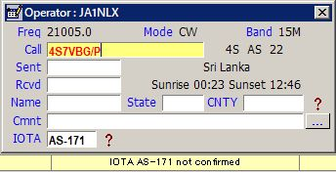

DXSW_7

**Highlight callsign cells only**

Changes the general row highlighting to cover the callsign column only

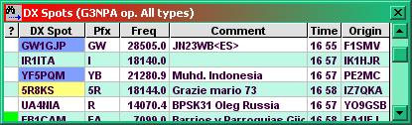

DXSW_8

### Enable DX Spot Freeze

Mouse wheel or scroll bar activity, freezes incoming spots for 10 seconds in DX Spot Window. This should be enough time for the user to browse the history and click on a line. Following a mouse click, the freeze is canceled. During this freezetime, incoming spots are suppressed.

During the period that the software holds off incoming spots Title bar changes to display the fact that a "Freeze" is in effect. The series of dots following the word "Freeze" will display a count down to the freeze being released automatically if no further action is taken.

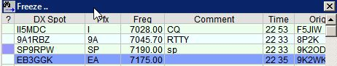

DXSW_39

Those using a mouse configuration where Windows does not see mouse wheel events can simply scroll using the scroll bar

**Enable overwrite of visible duplicate DX Spots**

This option enables/disables the overwriting of duplicate DX Spots that are visible on the DX Spot Window.  The default is enabled.  As before, duplicate DX Spots that are visible on the DX Spot are simply overwritten with data from the new DX Spot.  If this option is disabled, then when a duplicate DX Spot is received where the original DX Spot is still visible on the DX Spot Window, the old DX Spot is removed and the new DX Spot is added to the end of the DX Spot Window

**If the first word of comments is a mode, use it**

A DX Spot for a FT8 Fox/Hound station is outside the normal band segment, so the highlight colors and tooltips are not for FT8, but maybe RTTY or something depending on the BandPlan settings.  If the first word of the comments field is FT4 or FT8 or FOX or HOUND (and you have the new option checked), then Logger32 does not use the mode from the BandPan, but uses the mode from the comments.

Clicking on an FT8 DX Spot in the RTTY band segment should now adjust the following:

DXSpot tooltips should show FT8 want/need.   
 Lower status bar should show FT8 want/need   
 Logbook Entry Mode should show FT8 (even if WSJT/JTDX not running)

If there is a BandPlan entry for FT8 on this band, radio should switch to the radio mode for FT8. If there is no BandPlan entry for FT8 on this band, the radio should switch modes to the first FT8 entry it finds in the BandPlan. If there is no FT8 entry anywhere in the BandPlan, the radio should switch to SSB.

**Show talk messages**

Talk messages will be displayed in the DX Spot window.